**E-Commerce Writeup**

* Prepare a table of Sales and Profit month-wise in a working sheet.

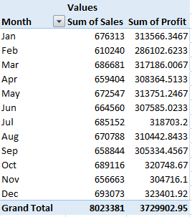

* Prepare the sales table region-wise in the working sheet.

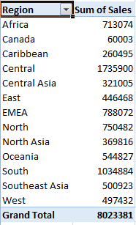

* Create a Column Chart of the month-wise table and region-wise table.

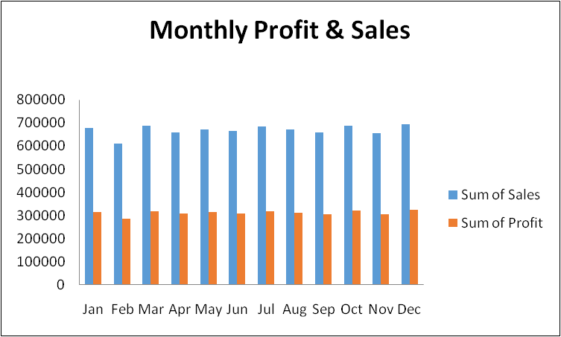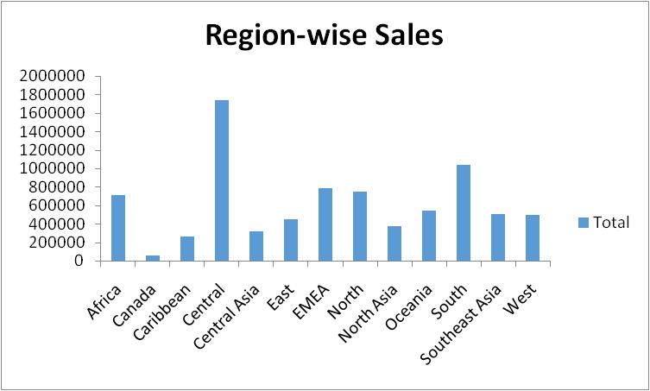

* Create chart for No. of orders ageing wise.

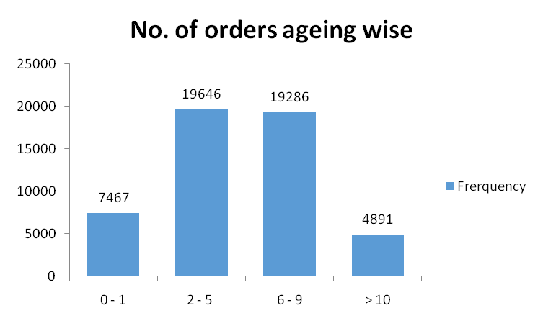

* E-Commerce Dashboard

